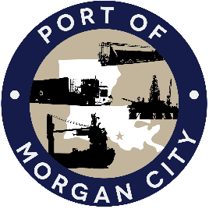

NOTICE OF PUBLIC MEETING

MORGAN CITY HARBOR AND TERMINAL DISTRICT

Notice is given that a special meeting of the Board of Commissioners of the Morgan City Harbor and Terminal District (“District”) has been called by Joseph Cain, President of the Board of Commissioners, and will be held at 7327 Highway 182, Morgan City, Louisiana on Tuesday, December 7, 2021 at 8:30 a.m. for the following purposes and to take appropriate action thereon, to wit:

AGENDA

- Call to Order

- Roll Call

- Discussion and any action on purchase of land currently leased from LHE, Inc.

- Adjournment

In accordance with the Americans with Disabilities Act, if you need special assistance, please contact Tori Henry at 985-384-0850, describing the assistance that is necessary.

